**PRS Inspection Plan**

**Introduction**

1. The Council is committed to improving standards in the PRS and this is reflected in Priority 2 in the Private Sector Housing Policy 2016-19, which contains the objective, “significantly improve management and property conditions and reduce ASB in the PRS”. The action associated with this objective is to assess the evidence, identify the best option and subject to legal advice and DCLG approval if necessary, commence the introduction of a Selective Licensing Scheme for PRS single occupied dwellings.

**Selective Licensing**

2. Under Part 3 of the Housing Act 2004 a local housing authority can designate the whole or any part or parts of its area as subject to selective licensing. Where a selective licensing designation is made it applies to privately rented property in the area. Subject to certain exemptions specified in the Selective licensing of Houses (Specified Exemptions) (England) Order 2006, all properties in the private rented sector which are let or occupied under a licence, are required to be licensed by the local housing authority, unless the property is a House in Multiple Occupation and is required to be licensed under Part 2 of the Act.

3. Local authorities are required to show how a selective licensing designation will improve an area, and how the designation will work alongside other existing policies or measures that are already being taken i.e.

1. the authority must ensure that any exercise of the power is consistent with the authority’s overall housing strategy;
2. the authority must also seek to adopt a co-ordinated approach in connection with dealing with homelessness, empty properties and anti-social behaviour, both:

* as regards combining Selective Licensing with other courses of action available to them; and
* as regards combining Selective Licensing with measures taken by other persons.

c) they have considered whether there are any other courses of action available to them (of whatever nature) that might provide an effective method of achieving the objective or objectives that the designation would be intended to achieve, and

d) they consider that making the designation will significantly assist them to achieve the objective or objectives (whether or not they take any other course of action as well).

4. A selective licensing designation may be made if the area to which it relates has high levels of private rented stock (currently the national average of the PRS is 20% of the stock) and the area is experiencing one or more of the following conditions:

• low housing demand (or is likely to become such an area);

• a significant and persistent problem caused by anti-social behaviour;

• poor property conditions;

• high levels of migration;

• high level of deprivation;

• high levels of crime.

5. The guidance from DCLG states that authorities must use the data from the 2011 Census to calculate the level of private rented stock in an area.

6. With effect from 1 April 2015, a new General Approval came into force which required Local authorities to obtain confirmation from the Secretary of State for any selective licensing scheme which would cover more than 20% of their geographical area or would affect more than 20% of privately rented homes in the local authority area.

7. Under the new arrangements if a local housing authority makes a designation that covers 20% or less of its geographical area or privately rented properties, the scheme will not need to be submitted to the Secretary of State, provided the authority has consulted for at least 10 weeks on the proposed designation. However, if the local housing authority makes one or more designations that are in force partly concurrent to an existing scheme, and cumulatively all the designations cover more than 20% of the area or the private rented stock, those new designations will need to be submitted to the Secretary of State for approval. Likewise if the local housing authority makes two or more designations at the same time, each of which account for less than 20% of the area or private rented stock, but cumulatively account for more than 20% of either, all of the schemes will need to be submitted to the Secretary of State for confirmation.

8. When considering whether to make a selective licensing designation a local housing authority must first identify the objective or objectives that a designation will help it achieve. In other words it must identify whether the area is suffering problems that are caused by or attributable to any of the criteria for making the designation and what it expects the designation to achieve - for example, in Oxford our aim would be an improvement in property conditions in the designated area.

9. Secondly, it must also consider whether there are any other courses of action available to it that would achieve the same objective or objectives as the proposed scheme without the need for the designation to be made. For example, if the area is suffering from poor property conditions, is a programme of targeted enforcement an alternative to making the designation?

10. Only where there is no practical and beneficial alternative to a designation should a scheme be made.

11. It is possible to identify the wards in the City which meet the DCLG criteria of high levels of PRS i.e. 20% and above and where the BRE Stock Condition Survey indicates poor property conditions exist.



12. Using the data it is possible to create 2 readily identifiable options: Option 1 that meets both PRS and disrepair criteria and Option 2 that meets PRS, disrepair and contains higher than the national average of category 1 hazards using the HHSRS rating scheme.

|  |  |
| --- | --- |
| Option 1 - PRS and disrepair | Option 2 - PRS, disrepair and HHSRS |
|  |  |

13. However, discussions with DCLG have revealed that Option 1 is highly unlikely to be acceptable as the area covered by a Selective Licensing Scheme would be too large.

14. The area covered by Option 2 does not cover those parts of the City that generate the most concern and result in the highest levels of enforcement action.

15. It is possible to further analyse the data and reduce the number of qualifying wards for the following reasons:

|  |  |
| --- | --- |
| **Ward** | **Comments** |
| Barton and Sandhills | 19.9% PRS so under 20% threshold |
| Carfax | City centre - PRS mainly University controlled |
| Holywell | City centre - PRS mainly University controlled |
| Littlemore | 19.7% PRS so under 20% threshold |
| North | Low enforcement activity |
| St Margaret's | Low enforcement activity |
| Summertown | Low enforcement activity |

16. This results in a third option which is shown below:

Option 3

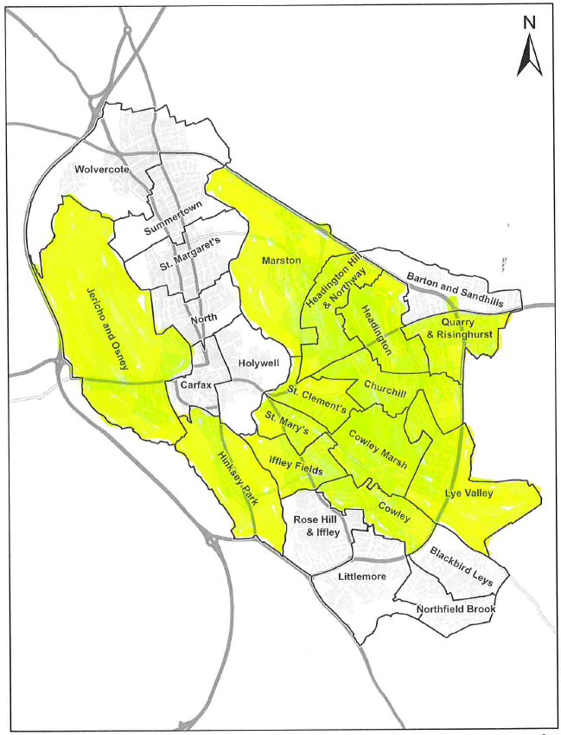

17. However, this does not address the fact that areas where there are high levels of enforcement such as Rose Hill remain outside the area controlled by licensing. It is worth noting the concentration of notices served in Blackbird Leys, Rose Hill and Northfield Brook where PRS levels are the lowest in Oxford:

|  |  |
| --- | --- |
| Formal Enforcement Action | Service Requests by Ward 2015 |
|  |  |

**Background to Financial Penalties**

18. It is apparent that the new powers granted in April 2017 to local authorities under the Housing and Planning Act 2016 to issue Financial Penalties have changed the regulatory landscape.

19. Landlords and Agents have regularly argued that local authorities should use their existing powers to proactively target rogue landlords instead of introducing licensing schemes that impact on every landlord and not just the non-compliant. Local authorities have countered that argument by stating that the available powers do not provide them with sufficient disincentive to deter rogue landlords from entering or remaining in the market and that the cost of proactive regulation is prohibitive.

20. The new Financial Penalties offer a potential solution for local authorities as the ability to issue a fine up to £30k is a significant deterrent and secondly, the Council retains the money from the fine instead of it going to the government. There is a legal requirement that any revenue derived from Financial Penalties must be used to regulate the PRS or it has to be returned to the government.

21. It would therefore be possible for any revenue from Financial Penalties to be placed into a ring fenced account and used to finance targeted proactive inspections of properties in the non-HMO PRS.

22. In addition, to go ahead and introduce a Selective Licensing Scheme without a period of using Financial Penalties to regulate the PRS could provide an opportunity for landlords and agents to criticise the Council’s case for licensing and may increase the possibility of a legal challenge.

23. However, one weakness in the use of Financial Penalties is that their impact is reduced without the benefit of a licensing framework in which to operate. Out of the five offences under the Housing Act 2004 for which a Financial Penalty can be issued, three relate to licensing and of the two remaining offences only the offence of failing to comply with an Improvement Notice is likely to occur. Section 126 and Schedule 9 of the Housing and Planning Act 2016 limit Financial Penalties to the following offences:

• Failure to comply with an Improvement Notice (section 30);

• Offences in relation to licensing of Houses in Multiple Occupation (section 72);

• Offences in relation to licensing of houses under Part 3 of the Act (section 95);

• Offences of contravention of an overcrowding notice (section 139)

• Failure to comply with management regulations in respect of Houses in Multiple Occupation (section 234).

24. Nevertheless it is worthwhile examining the current non-HMO intervention work and considering how using Financial Penalties may impact upon the programme and provide an alternative to Selective Licensing.

**Current Proactive PRS Interventions**

25. Enforcement in the non-HMO PRS is carried out by the Private Sector Safety Team, which currently has the following resource:

|  |
| --- |
| Team Leader Private Sector Safety |
| Principal Lead Officer (Private Sector Safety) |
| Environmental Health Officer |
| Environmental Health Officer |
| Environmental Health Officer |
| Environmental Health Officer |
| Environmental Health Officer/ Planning Enforcement Officer |
| Planning Enforcement Officer |
| Apprentice |

26. The Team carries out a wide range of statutory functions and interventions and services include dealing with poor dwelling conditions or energy performance in rented and owner occupied homes (e.g. hoarding), unlawful dwellings, licensing of caravan/mobile home parks, public health burials, the Landlords/Agents Redress Scheme, the Oxford City Landlords Accreditation Scheme and landlord/agent training and statutory nuisance investigations e.g. tents on land and pollution from canal boats. The Team also carries out the Council’s Planning Enforcement function and supports other services priorities via multi-agency work such as empty homes and waterways issues.

27. The Private Sector Safety Team currently carry out a proactive inspection programme in the non-HMO PRS. They have a target of 275 property inspections per year. The properties are selected by the following three methods:

* Using EPC data where a rented property has an F or G rating
* Whole house inspections are carried out following a service request from a tenant
* Known problem portfolios are selected for inspection

28. The proactive inspections carried out involve a full HHSRS inspection of the property and enforcement action is taken in line with the Council’s Enforcement Policy.

29. In non-HMO rental properties the primary enforcement option is the service of a notice. The type of notices served by the Council depends on the situation and circumstances found. Certain notices exist within legislation to enable the Council to gather information as part of a formal investigation. There are also specific notices for dealing with Category 1 and Category 2 hazards under Part 1 of the Housing Act 2004. The table below provides the breakdown of type of legal notices served and shows that during 2015 around 50% of the notices served were under Part 1 of the Housing Act 2004, which indicates that category 1 hazards existed under the Housing, Health and Safety Rating Scheme. Category 1 hazards are serious issues such as exposed wiring, a dangerous or broken boiler, a leaking roof and broken steps at the top of the stairs. The number of Housing Act notices (HA04) served is higher than expected when using the BRE estimate of 15% of properties having category 1 hazards.

|  |  |  |  |
| --- | --- | --- | --- |
|  | Inspections | HA04 Notices served | Other notices served |
| 2014/15 | 220 | 33 | 88 |
| 2015/16 | 250 | 73 | 137 |
| 2016/17 | 275 | 77 | 162 |
| 2017/18 Q1 | 54 | 29 | 42 |

**The Financial Penalties Option**

30. The number of prosecutions and formal cautions issued as a result of enforcement action in the HMO sector has increased steadily since citywide licensing was adopted. Where appropriate Financial Penalties are now being considered as an alternative to prosecutions and it is anticipated that from now on prosecution will be reserved for the very serious cases. Financial Penalties will completely replace formal cautions as an enforcement option.

31. Using the figures in the table below it is estimated that there will be approximately 25 cases per year that will result in a Financial Penalty being issued.

32. It is difficult to estimate the average amount levied for a Financial Penalty as each case is based on its merits. There is an appeal mechanism available to the First Tier Tribunal and as yet there are no examples of how appeals are being dealt with by the Tribunal, so it is not possible to say whether the levels of Financial Penalties issued by local authorities will be upheld or reduced on appeal. It is anticipated that a significant number of Financial Penalties will be appealed because the cost of an appeal is low and costs are rarely awarded against appellants. In addition a Financial Penalty is a civil debt and so recovering the fine is unlikely to be a straightforward process.

33. With all these uncertainties an estimate of an average of £5k per Financial Penalty has been made which provides an estimated annual fine level of £125k.

34. It is proposed that a ring fenced account is set up for all Financial Penalty revenue as per the government’s requirement for fines to be spent on PRS enforcement and that this is used to fund additional resource on a fixed term basis for PRS enforcement. The level of resource to be funded each year would be agreed with Finance (including contributions to central overheads) and any money in excess of the agreed level could be used to fund additional resources for elsewhere in the service or to secure longer term employment for existing staff.

35. It is anticipated that over the period of the first 5 years after the introduction of Financial Penalties there may be a change in behaviour in landlords in the sector and that the number of offences might decline. The impact of significant fines should mean that the poorer landlords will either be driven from or exit the market or they will accept that better standards are required and make arrangements to improve the management of their properties.

36. The full cost of a Grade 7 Environmental Health Officer, including on costs is £45k-£46.5k. It should therefore be possible to recruit 2 FTE on a 12 month contract and utilise the additional resource to carry out proactive citywide inspections of non-HMO PRS properties. As these officers would not be involved in the reactive workloads and non-PRS work of the service they would be able to focus on the tasks of inspection and enforcement. It is estimated that each FTE will be able to carry out 180 proactive inspections per year.

**Additional Resource from DCLG funding & reviewing priorities**

37. The Service has very recently been advised that it has been successful in bidding for £275k from the DCLG which will provide 3 additional staff for 2 years to reinvigorate the work on Unlawful Developments (Beds in Sheds) in the City. This work is proactive in nature and is closely linked to the PRS intervention programme as unlawful developments are often connected with rented properties so it is highly likely that there will be sufficient crossover in work stream opportunities to use this resource to increase the overall number of proactive inspections.

38. A review of the existing priorities in the Private Sector Safety Team with a greater focus on work in the PRS will allow for an uplift in the annual target of proactive inspections:

|  |  |
| --- | --- |
|  | Proactive inspections |
| Current resource | 290 |
| Funded by Financial Penalties | 360 |
| Unlawful Developments | 50 |
| Total per annum | 700 |

**Proposed Targets**

39. Whilst the BRE estimate is that 15% of the properties in Oxford contain category 1 hazards and 13% are in disrepair, the findings so far from the proactive inspection programme over the last 2 years is that the average is actually 28%.

40. Using the 2011 Census data the number of inspections required can be calculated:

|  |  |
| --- | --- |
| Census estimate | 12,305 |
| Proactive inspections already completed 2014-17 | 745 |
| Remaining estimate | 11,560 |
| Estimated number with category 1 hazards (28%) | 3,236 |

41. As the DCLG funding will end after 2 years the proposed inspection scheme profile (subject to funding from Financial Penalties) is given below:

|  |  |  |  |  |  |
| --- | --- | --- | --- | --- | --- |
| 2017/18 | 2018/19 | 2019/20 | 2020/21 | 2021/22 | Total |
| 700 | 700 | 650 | 650 | 650 | 3,300 |

42. The address of every property that contains a category 1 hazard is not known so the programme will require significant targeting as it can only be estimated whether a property actually contains category 1 hazards. There will also have to be work carried out to identify properties that are in the non-HMO PRS as this information is not readily available. The Investigation Support Officer funded by the successful DCLG bid will be able to assist in this data exercise as they will be identifying properties for investigation as possible unlawful developments.

**Conclusion**

43. The option that will provide the most effective and flexible equitable approach is the adoption of a proactive inspection programme using the funding from civil penalties.

44. In particular it will:

* Build on and use intelligence from existing work and related licensing activities
* Mitigate the concern about a citywide or large scale scheme which is no longer an option with Selective licensing
* Provide regulatory coverage in areas of high concern that would not be covered by Selective Licensing
* Prevent problem landlords defaulting into areas where licensing is not in force
* Not create areas where the better landlords perceive that they are being unfairly targeted